Attendance Automation:
Start

Site Wise Attendance receive

Present?

No
Yes
Leave Applied?
Site wise attendance report will be generated

Total Log hour = 8hr 45min 00sec? & Log In time <=11:00PM

Log
Yes
No
Send notification on 1st date of every month

No
1st or 3rd Saturday=5Hr 45Min 00Sec? & Log In time <=11:00PM

Yes Yes No
Calculate and Show late days
Not count as late days

Automated Notification will send to the recipient and can give feedback on the same

Make adjust based on feedback

Based on adjustment auto leave need to deduct as per policy from CL & Pl balance.

Send leave deduction notification

Stop
- Site wise attendance data will receive from biometric system.
- If employee biometric receive then wise Site wise reporting time will show in report. If employee biometric not receive then check leave application for that day, if available then stop the process if not available then give option to the employee for leave application.
- Check total time= 8 hour 45 min 00sec. If yes then not count as late days. If not then show total late days and send total late days notification to recipients.
- Also check everyday Log-in time = 11 AM then count as late days.
- User can give feedback via mail response.
- Admin can adjust late days according to received feedback.
- Based on that adjustment, calculate total leave balance amount need to deduct will show.(1 day leave balance =3 working days late). Leave balance need to deduct from ‘Casual Leave’. If casual leave=0 then deduct from ‘Privilege Leave’. If Privilege Leave=0 the deduct salary as per days.
- Lastly, based on deduction send notification to the employee/recipient.
Late attendance view for Employee:

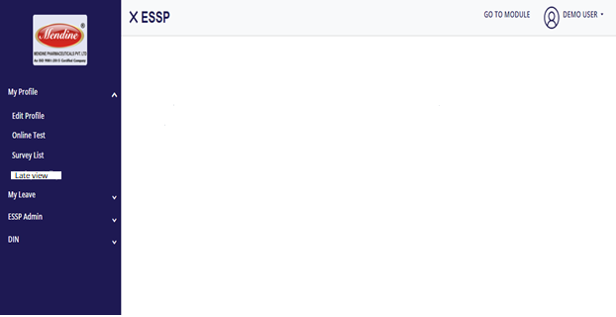
Apply
February:
Sl. No | Employee Name | Late Days |  | Leave Count |  | Leave Deduction Status
1 | Demo User | 02/02/23,03/02/23,06/02/23 |  | 1day |  | Deducted from CL balance
Not applied Leaves:

Sl No | Employee Name |  | Absent Days |  | Leave Count |  | Action

Late Days Details
1ST
FEB
2ND
FEB
3RD
FEB
4TH
FEB
5TH
FEB
6TH
FEB
2nd February, Thursday
Log In time: 09:52:18 AM Log-In Location: IECSL office
Log Out time: 06:30:45 PM Log-Out Location: IECSL office
Total working Hours: 08Hr : 38Min : 27Sec
Deficit Working Hours: 00Hr : 07Min : 33Sec
6th February, Friday
Absent: Leave not applied

Apply leave

- After clicking ‘Apply Leave’ it will redirect to leave application page.
Admin View:
Late attendance view:
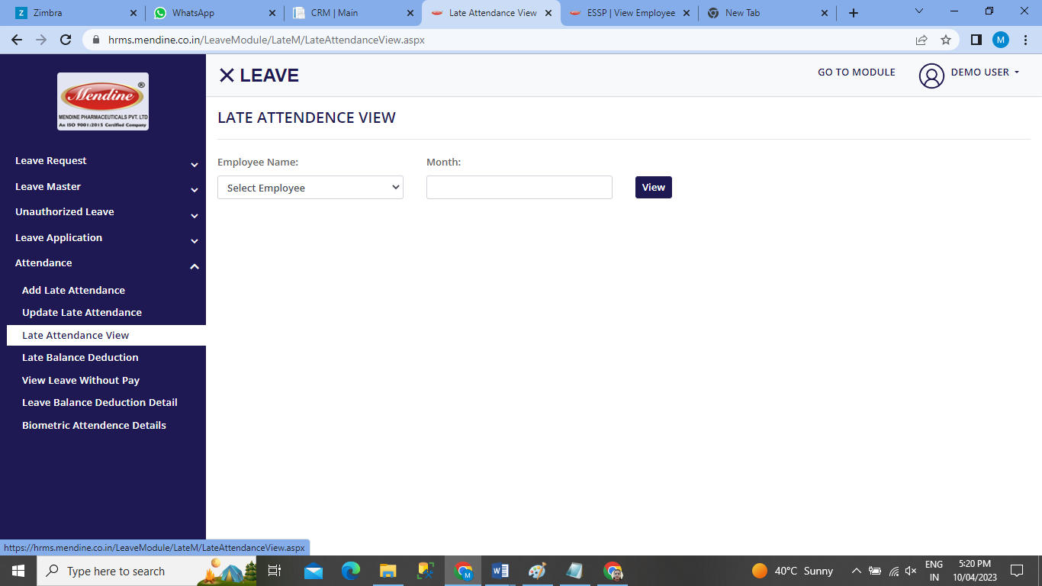
Sl. No | Employee Name | Late Days | Leave Count | Leave Deduction Status
1 | Demo User | 02/02/23,04/02/23,06/02/23 | 1day | Deducted from CL balance
2 | Arun Dutta | 05/02/23, 06/02/23
3 | Suraj Singh
Not applied Leaves:
Sl. No | Employee Name | Absent Days | Leave Count | Leave Status

Current Month( March) Late attendance View

- Add late attendance and update late attendance menu not required.

